|  |  |  |  |  |  |  |  |  |  |
| --- | --- | --- | --- | --- | --- | --- | --- | --- | --- |
| **附件1**  **2023年三林镇农村公路设施量调整明细表** | | | | | | | | | |
| **三林镇（盖章）** | | | | | | | | | |
| **序号** | **路名** | **道路等级** | **道路** | | | | **调整里程（KM）** | **变更桥梁名称** | **备注** |
| **现状** | | **变更后** | |
| **里程（KM）** | **起讫点** | **里程（KM）** | **起讫点** |
| 1 | 红临路 | 村道 | 0.29 | 浦星公路--林培路 | 无 | 无 | -0.29 |  |  |
| 2 | 红旗南路 | 村道 | 0.16 | 三鲁公路--林德路 | 无 | 无 | -0.16 |  |  |
|  |  |  |  |  |  |  |  |  |  |
|  |  |  |  |  |  |  |  |  |  |
| **合计** | | | 0.45 |  |  |  | -0.45 |  |  |

**附件2**

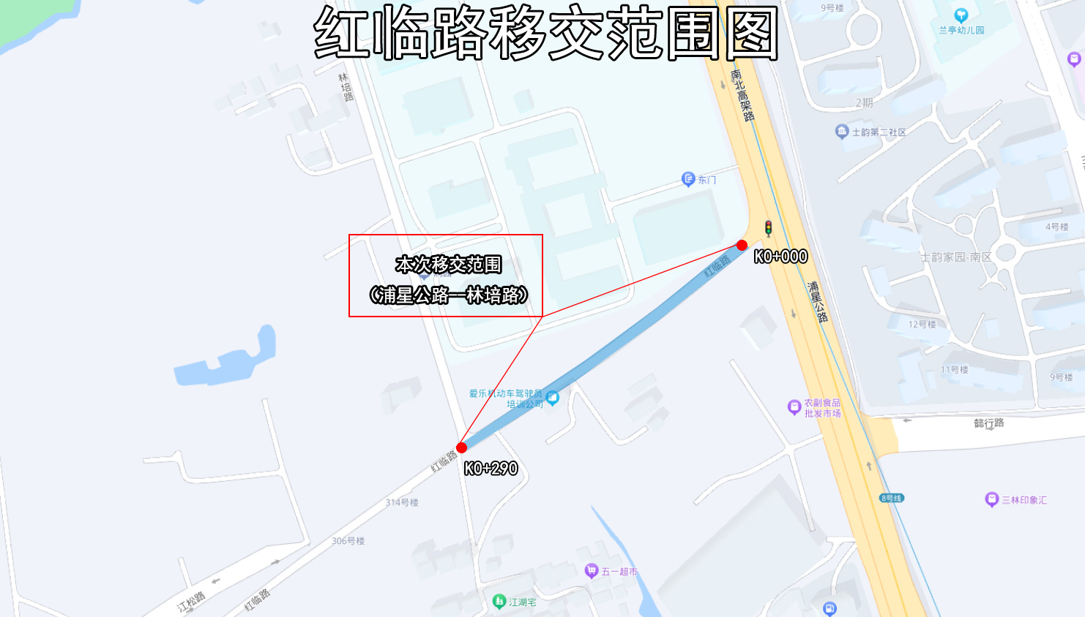

**附件3**

